Lab 2 assignment
-Go to the UCSC genome browser (genome.ucsc.edu).
-Use assembly Human Dec. 2013 (GRCh38/hg38)
-Enter ALDH2 into the search field and hit Return
-Select one of the RefSeq entry link ALDH2 at chr12:11766933-111817531
-Show the tracks listed below, hide all others and Refresh

Track Name Setting
Mapping and Sequencing Base Position Dense
Genes and Gene Prediction NCBI RefSeq Full
Phenotype and Literature GWAS Catalog Dense
Expression GTEx Gene Full
Regulation ENCODE Regulation Show
Variation CommonSNPs (150) Dense

Go to Genes and Gene Predictions, click on NCBI RefSeq and configure the NCBI RefSeq track to show only RefSeq Curated as shown and hit submit.

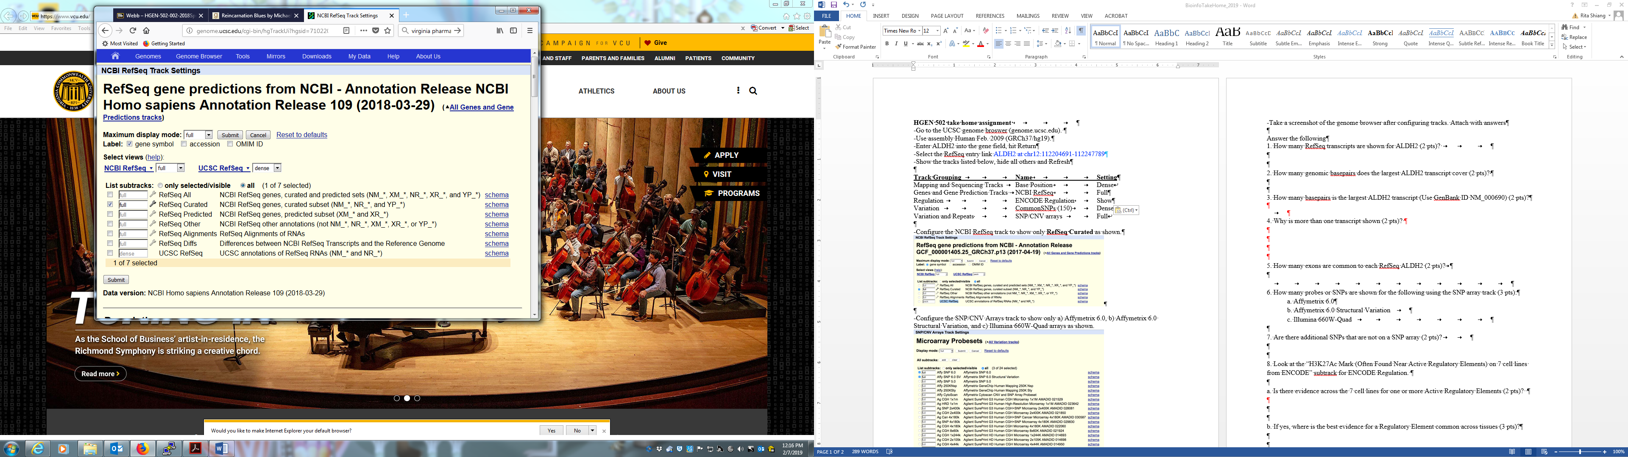

Take a screenshot of the genome browser after configuring tracks. Attach with answers to the following : 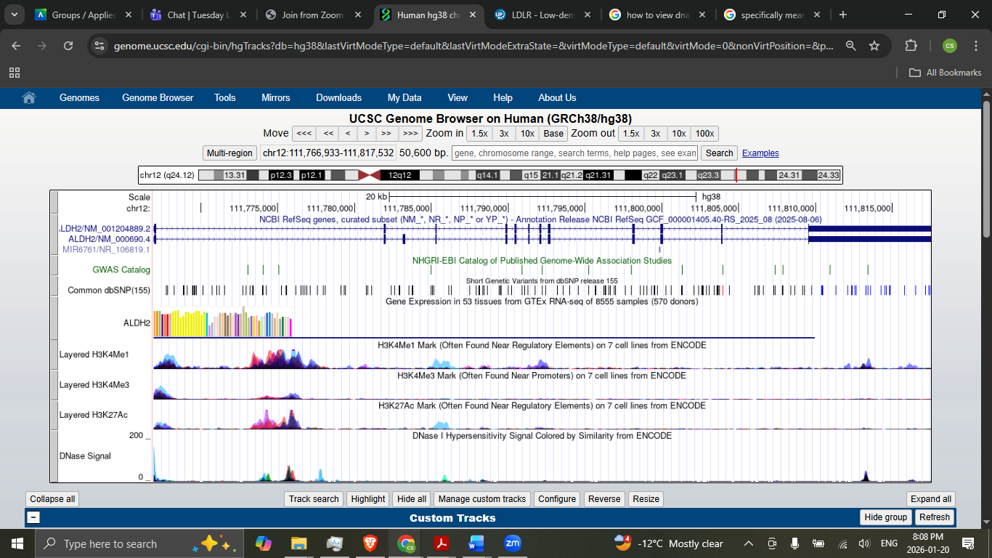
1. How many RefSeq transcripts are shown for ALDH2 ?
There are 2 RefSeq transcripts for ALDH2

2. Why is more than one transcript shown?
Each transcript represents a different isoform

3. How much genomic DNA in basepairs does the ALDH2 RefSeq transcript with the most exons cover ?
50,600 base pairs

4. How many basepairs is the ALDH2 RefSeq transcript with the most exons (Use GenBank ID NM_000690.4) ?
50,600 basepairs

5. Is the direction of transcription of ALDH2 from centromere to telomere or from telomere to centromere ?
In the direction of the telomere (+)

6. In the Association Studies track SNP rs10744777 has been associated with what phenotype ?
Intronic Variant

7. What is the tissue that ALDH2 is highest expressed from the GTEx RNAseq project and the level of expression ?
Most expressed in the Liver ~600 RPKM on average

8. What is the level of expression of ALDH2 in the heart from the HPA RNA-seq normal tissue found at NCBI (https://www.ncbi.nlm.nih.gov/)? Is it greater or less than the expression above ?
The max expression of ALDH2 in the heart is on average 11.73 RPKM

9. Go back to UCSC and look at the “H3K27Ac Mark (often found near active regulatory elements) on 7 cell lines from ENCODE. In what region of the ALDH2 gene is there the best evidence for an active regulatory elements ?
Intron 1 shows the most evidence for an active regulatory element with some evidence suggesting exon 1 is also a region for active regulation

10. Are there any common nonsynonymous SNPs in ALDH2 ?
No

11. In what pathway is the ALDH2 gene involved ?
KEGG - Kyoto Encyclopedia of Genes and Genomes
hsa00010 - Glycolysis / Gluconeogenesis
hsa00053 - Ascorbate and aldarate metabolism
hsa00071 - Fatty acid metabolism
hsa00280 - Valine, leucine and isoleucine degradation
hsa00310 - Lysine degradation
hsa00330 - Arginine and proline metabolism
hsa00340 - Histidine metabolism
hsa00380 - Tryptophan metabolism
hsa00410 - beta-Alanine metabolism
hsa00561 - Glycerolipid metabolism
hsa00620 - Pyruvate metabolism
hsa00640 - Propanoate metabolism
hsa00650 - Butanoate metabolism
hsa00903 - Limonene and pinene degradation
hsa01100 - Metabolic pathways
BioCyc Knowledge Library
2PHENDEG-PWY - phenylethylamine degradation I
PWY-0 - putrescine degradation III
PWY-6313 - serotonin degradation
PWY-6342 - noradrenaline and adrenaline degradation
PWY66-161 - ethanol degradation III
PWY66-162 - ethanol degradation IV
PWY66-21 - ethanol degradation II
PWY66-401 - superpathway of L-tryptophan utilization
Reactome (by CSHL, EBI, and GO)
Protein P05091 (Reactome details) participates in the following event(s):
R-HSA-71723 acetaldehyde + NAD+ => acetate + NADH + H+ [mitochondrial]
R-HSA-380608 5-hydroxyindole acetaldehyde to 5-hydroxyindole acetic acid
R-HSA-71384 Ethanol oxidation
R-HSA-380612 Metabolism of serotonin
R-HSA-211945 Phase I - Functionalization of compounds
R-HSA-380615 Serotonin clearance from the synaptic cleft
R-HSA-211859 Biological oxidations
R-HSA-112311 Neurotransmitter clearance
R-HSA-1430728 Metabolism
R-HSA-112315 Transmission across Chemical Synapses
R-HSA-112316 Neuronal System

